# Task 2 – Rohit Garg

## Objective

To find relationship between mortality rate (cancer, Alzheimer's disease and obesity).

* **Cancer:** There are 300 observations (50 States and 6 years from 2014 to 2019)
* **Alzheimer's disease:** There are 300 observations (50 States and 6 years from 2014 to 2019)
* **Obesity:** There are 50 observations (50 States and 1 year that is 2019)

## Data

There are 300 rows and 5 columns.

* Cancer and Alzheimer's disease are merged on Year and State
* Obesity is merged on State (it is assumed that Obesity is same for all the years)

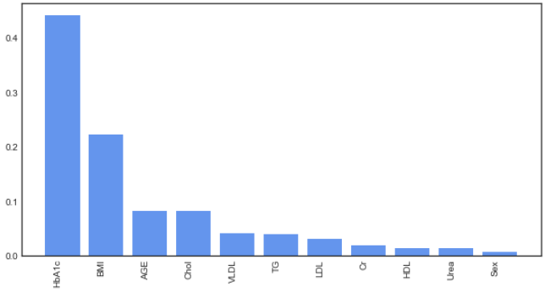

## Correlation

### Correlation matrix

It is observed that mortality rate from Cancer and Alzheimer's disease are highly correlated

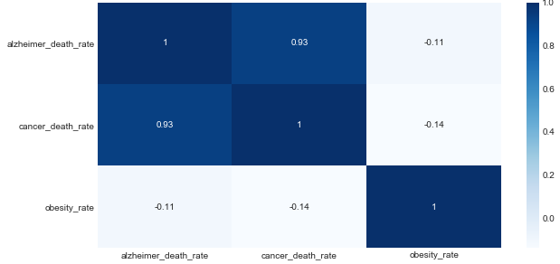

### Scatter plot

It is observed that there is linear relationship between mortality rate from Cancer and Alzheimer's disease

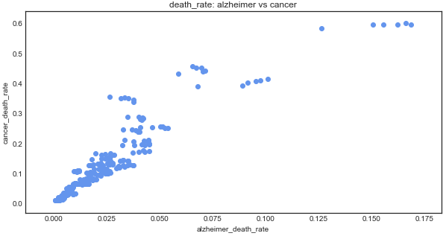

### Yearly trend

The data is rolled up at year and the average mortality rate for Cancer and Alzheimer's disease is calculated. It is observed that the mortality rate for both have increased from 2014 to 2019.

